

**2023 Sem-I**

Student Information Manual

AIDS



**Student Information Manual (SIM)**

###### Covering page Index



1. **Institute Information**
2. **Vision of Institute** Mission of Institute Quality Policy

###### Vision of Department

Mission of Department

Programme Educational Objectives (PEO’s) Programme Outcomes (PO’s)

Programme Specific Outcomes (PSO)

###### Students role Responsibilities:

Code-of-Conduct:

###### Laboratory and Classroom Instructions

Laboratory instructions: Classroom instructions:

###### Department Academic Planner

1. **Departmental time table**

###### Structure of Syllabus

1. **Subject Details** Course details/syllabus Recommended Books Teaching Plan

List of Experiment Assignments

###### Project/Seminar Review Form

Rubrics for Project Work assessment

###### Department Faculty

1. **Department Staff**

###### Activity Record

(Counseling, co/extracurricular, leave)



# INSTITUTE INFORMATION

Dr J. J. Magdum College of Engineering was established by Dr J. J. Magdum Trust, Jaysingpur in the year 1992 with an objective to promote the cause of higher education. The institute is approved by All India Council of Technical Education (AICTE), New Delhi and Government of Maharashtra, affiliated to Shivaji University, Kolhapur. The college offers B. Tech program in Mechanical, Civil, Computer Science Engineering, Electronics.

Our Management extends its fullest support in building the institution as a center of excellence with technically superior, ethically strong and competent engineers.

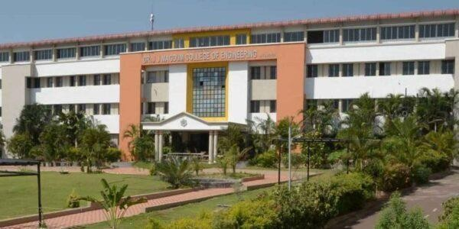The serene campus vibrant with aesthetic bliss in an exhilarating convenient location, well connected by road, rail and air is easily accessible. The eco- friendly ambience creates and bestows a healthy learning atmosphere.

The institution is meticulous with modern laboratory, workshop facilities and state of art computer center providing an excellent infrastructure.

The institution has spacious library with vast collection of Books, Newspapers, National & International Journals, Magazines, Reference books, Encyclopedia, World of science, ASM hand books and course materials. E-learning through NPTEL Video course by NIT and IIT Professors are available.

The Teaching and Non-Teaching Staff of the institute is a blend of senior experienced and young dynamic faculty members devoted to the noble cause of education. Qualified, experienced, versatile and efficient faculty members mold the students diligently in ethical, moral and academic aspects.

We impart technology based experiential learning through industry visits, live projects, expert talks, MOOC’s, workshops, case studies, upscale labs, and virtual classroom sessions.

Industry-Institute interaction and real-time projects nurture and craft the budding engineers to bloom and flourish in the field with the prowess guidance in the campus. The college equips the students with the latest skills which make them employable and future ready.

Due to able and proper guidance and motivation, many of our students have topped at University. Our training and placement work meticulously to improve and develop life skills to the students and tries hard to seek good jobs for our students. In addition to the academics, the students are engaged in sports and cultural activities which helps them to develop versatile personality. Various Club activities are conducted to encourage, motivate and inspire students from diverse culture to harness the talent through their perseverance.

The institute is having specious ground and the modern facilities for both indoor and outdoor games and ultra-modern Gymnasium. Due to proper guidance and motivation, many of our students have grabbed prizes at University level and different sport events.

We are committed to stakeholders for best results and produced more than 10000+ engineers getting campus placements.



# VISION OF INSTITUTE

To be a Leading academic organization, creating skilled and Ethical Human Resources by leveraging Technical Education for Sustainable Development of Society.



# MISSION OF INSTITUTE

* To promote learn ability of all stakeholders
* To empower rural youth to be competent in technical education and imbibe ethical values.
* To contribute to local social and economic context, leading to satisfied stakeholders.



# PROGRAMME OUTCOMES

We strive for continual improvement in our performance through methodical academic monitoring, student participation, and use of the innovative teaching- learning processes.



# 

# VISION OF DEPARTMENT

Empowering the future through transformative education, & developing globally competent engineers, motivated entrepreneurs, leading researchers, ethical & skilled professionals by driving innovation at the forefront of technology



# MISSION OF DEPARTMENT

* To Nurture skilled professional and globally competent engineers through education

and hands-on experience in cutting-edge technologies.

* To create research environment to lead advancements in technology, cultivating a community

of leading researchers dedicated to shaping the future.

* To Inspire entrepreneurial spirit by fostering innovation and creativity, preparing students

to thrive in the dynamic landscape of technology-driven industries.



# PROGRAMME EDUCATIONAL OBJECTIVES (PEO’S)

The Computer Science and Engineering Department strives for excellence in creating, applying and imparting knowledge in computer science and engineering through comprehensive education programs, research in collaboration with industry and service to professional societies, the community, the state, and the nation.

1. Learn and apply latest Software Technologies in the field of Computer Science & Engineering.
2. Identify real time problems and deliver innovative Software solutions for development of society To develop an ability for pursuing higher studies, research and development computer science and engineering, consultancy and entrepreneurshi



# PROGRAMME OUTCOMES (PO’S)

At the end of successful completion of program, the graduates will be able to,

* 1. **Problem Analysis**: Identify, formulate, research literature and analyze complex engineering problems reaching substantiated conclusions using first principles of mathematics, natural sciences and engineering sciences.
  2. **Design/Development of Solutions**: Design solutions for complex engineering problems and design system components or processes that meet specified needs with appropriate consideration for public health and safety, cultural, societal and environmental
  3. **Conduct investigations** of complex problems using research-based knowledge and research methods including design of experiments, analysis and interpretation of data and synthesis of information to provide valid
  4. **Modern Tool Usage**: Create, select and apply appropriate techniques, resources and modern engineering and IT tools including prediction and modeling to complex engineering activities with an under-standing of the limitations.
  5. **The Engineer and Society**: Apply reasoning informed by contextual knowledge to assess societal, health, safety, legal and cultural issues and the consequent responsibilities relevant to professional engineering
  6. **Environment and Sustainability**: Understand and the impact of professional engineering solutions in societal and environmental contexts and demonstrates knowledge of and need for sustainable development.
  7. **Ethics:** Apply ethical principles and commit to professional ethics and responsibilities and norms of engineering
  8. **Individual and Teamwork**: Function effectively as in visual, and as a member or leader in diverse teams and in multidisciplinary s
  9. **Communication:** Communicate effectively on complex engineering activities with the engineering community and with society at large, such as being able to comprehend and write effective reports and design documentation, make effective presentations and give and receive clear
  10. **Project Management and Finance**: Demonstrate knowledge and understanding of engineering and management principles and apply these too noels on work, as a member and leader instead, to manage projects and in multidisciplinary environment.
  11. **Lifelong Learning**: Recognize the need for and have the preparation and ability to engage in independent and life-long learning in the broadest context of tech



# STUDENTS ROLES AND RESPONSIBILITIES



CODE-OF-CONDUCT

* Every student must carry his/her identity card while being present on the College Premises. Use of Cell phones is strictly prohibited during class/Labs hour.
* Without the permission of the Principal, Students are not allowed to circulate any printed materials within the college campus.
* Every student is expected to maintain the general cleanliness within the classrooms, laboratories and the campus in general.
* Students should handle the college properties with care. Damage to the furniture or any other materials may lead to penalty or suspension from the college.
* Intoxication or possession of narcotics and other dangerous material is strictly prohibited.
* Playing cards, spitting and loitering are strictly prohibited inside the college campus and shall invite severe punishment/disciplinary action
* Attempted or actual theft of and/or damage to property of the College, or property of a member of the College community, or other personal or public property, on or off campus will be considered as a punishable act.
* Every student will remain answerable to the college authority for his/her activity and conduct on the College Premises.
* Any act which obstructs teaching, research, administrative activity and other proceedings of the college is strictly prohibited.
* Indulging ragging, anti-institutional, anti-national, antisocial, communal, immoral or political expressions and activities within the Campus and hostel are strongly prohibited as well as punishable.
* Students are required to check the Notice Board and also website of the college for important announcements.



# LABORATORY INSTRUCTIONS

 Students must present a valid ID card before entering the computer lab.  Remove your shoes/chapels/sandals outside the lab.

 Playing of games on computer in the lab is strictly prohibited.

 Before leaving the lab, students must close all programs positively and keep the desktop blank.

 Students are strictly prohibited from modifying or deleting any important files and install any software or settings in the computer without permission

 Based on the prime priority, users may be requested by the lab in-charge, to leave the workstation any time and the compliance is a must.

 Eating and/or drinking inside the computer lab is strictly prohibited.  Internet facility is only for educational/ study purpose.

 Silence must be maintained in the lab at all times.  The lab must be kept clean and tidy at all times.

 If any problem arises, please bring the same to the notice of lab in-charge.

 No bags/ hand bags/ rain coats/ casual wears will be allowed inside the computer lab, however note book may be allowed.

 Lab timing will be as per the academic time table of different classes  Every user must make an entry in the Computer Lab Register properly.

 Each student or visitor must take mobile phones in “Switched Off” mode while entering and or working in Computer Lab.

 Conversation, discussion, loud talking & sleeping are strictly prohibited.  Users must turn-off the computer before leaving the computer lab.

 Maintain silence in lab.

 Computer Lab Assistants are available to assist with BASIC computer and software problems.  Food and drink are not permitted in the computer lab.

 The use of cell phones is prohibited in the computer lab.

 Please take your calls outside. We also ask that you put your cell phone on vibrate mode.  Unauthorized copying and/or installing of unauthorized software is not permitted

 Tampering with the hardware or software settings will not be tolerated.

# CLASSROOM INSTRUCTIONS

Students should know and obey rules and regulations of department as well as college.



Students strive to meet Academic Expectations

students are expected to take all tests at the scheduled times seriously. Maintain discipline in the class

A student should maintain at least 75% attendance in the Lectures of every subject and 100% overall performance. Otherwise, he or she will be debarred from the University Examination.

Latecomers will not be entertained to enter into the classroom.



Participate in the activities organized in the Department as well as in the College.

While discussion, students should conduct and express themselves in a way that is respectful of all persons.

Develop positive attitudes;



Be cooperative and considerate. Welcome challenges.

Be helpful to others

Be kind, polite, and courteous to others Do the assigned work on time

Be prepared for classes with all necessary supplies. Be Respectful and Punctual

Be in the best of behaviors

# DEPARTMENT

# ACADEMIC PLANNER

**ACADEMIC PLANNER 2023-24**

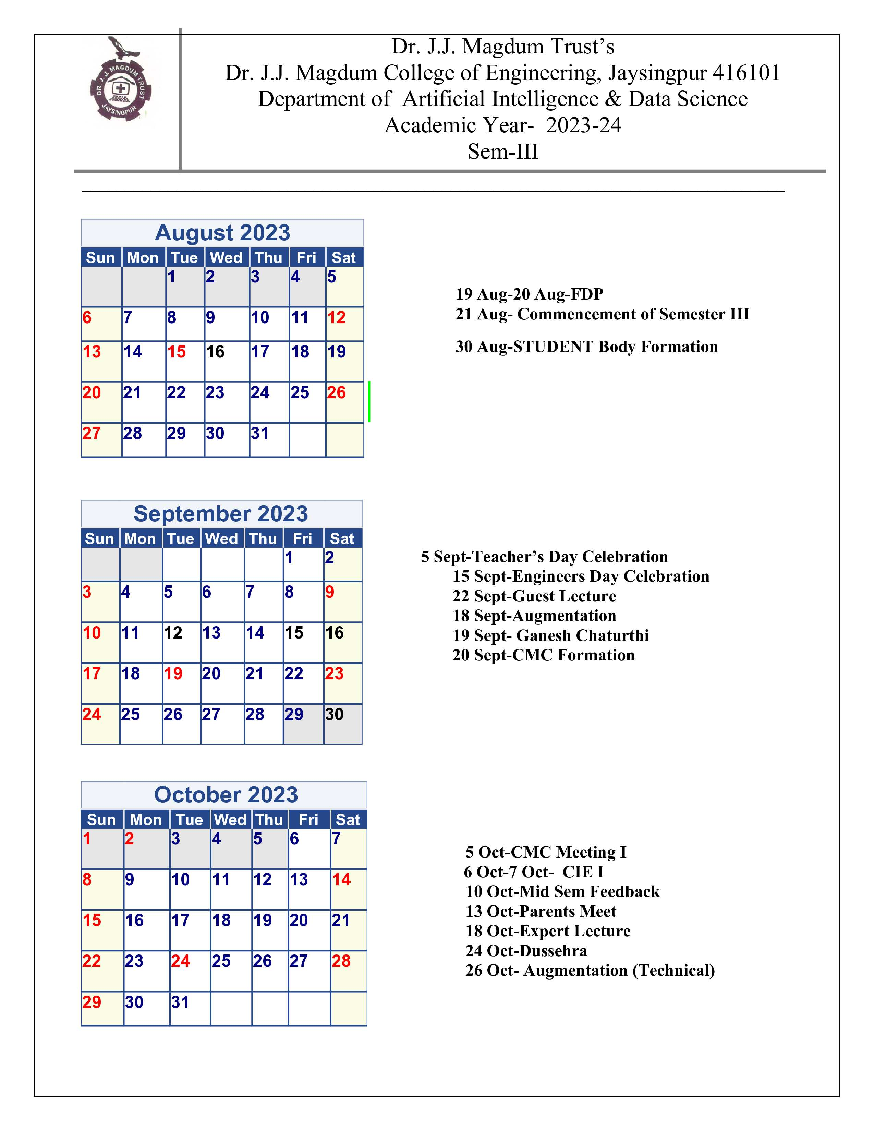

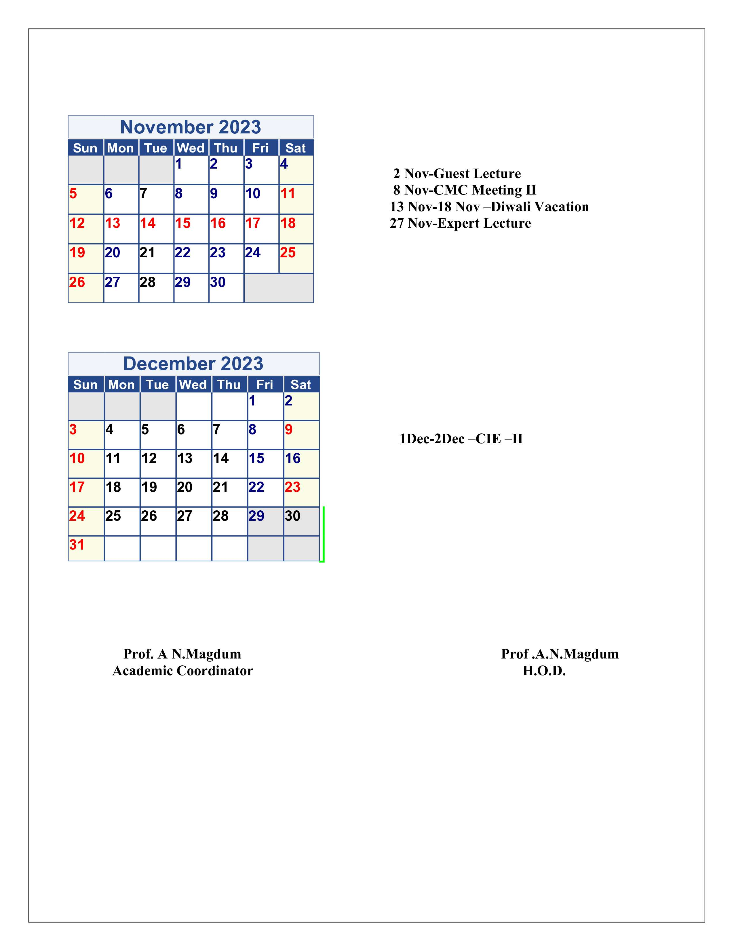

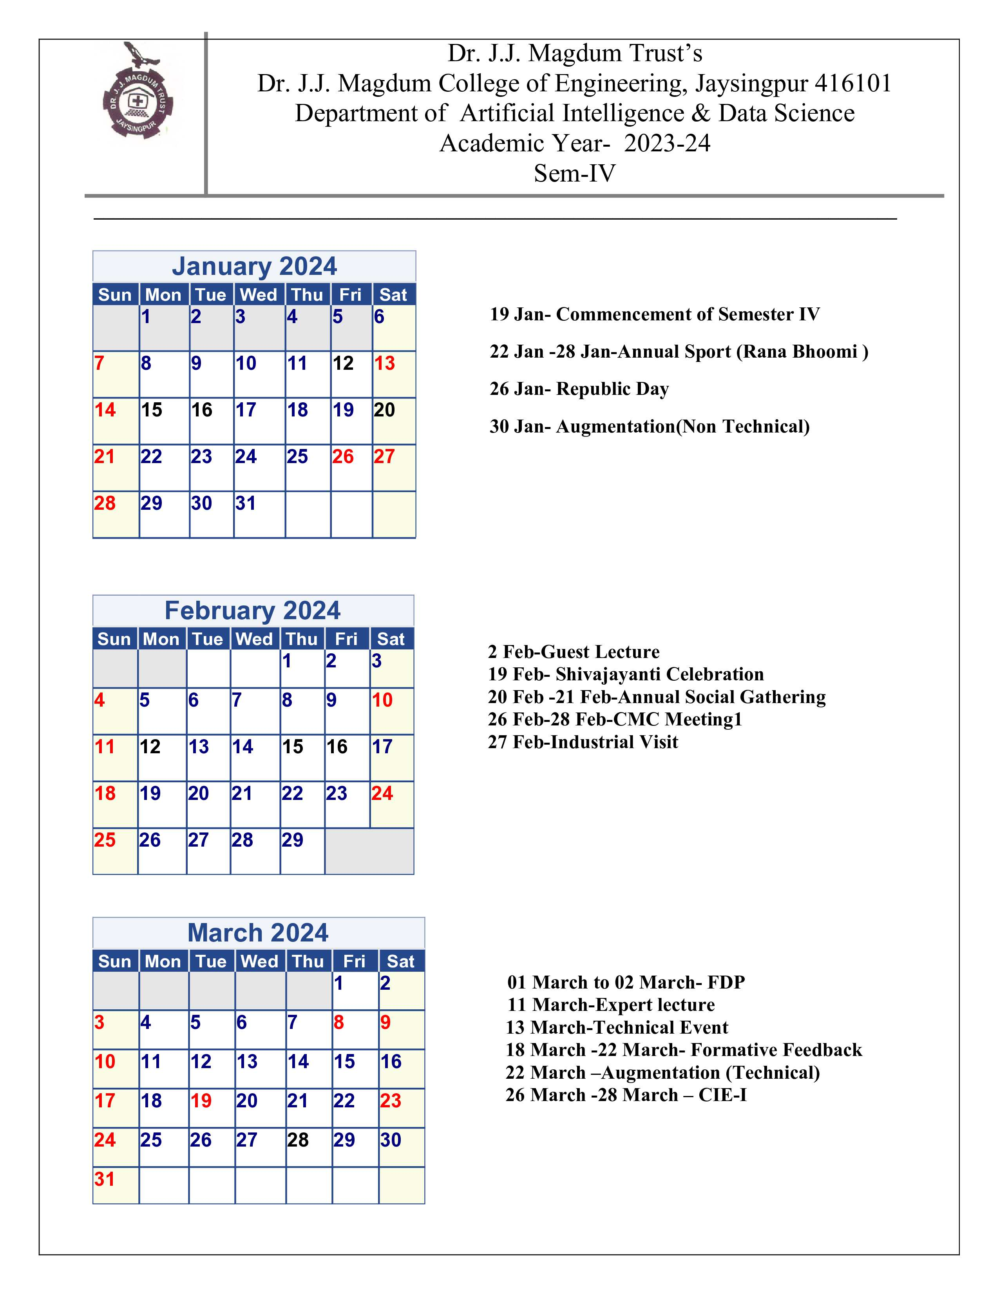

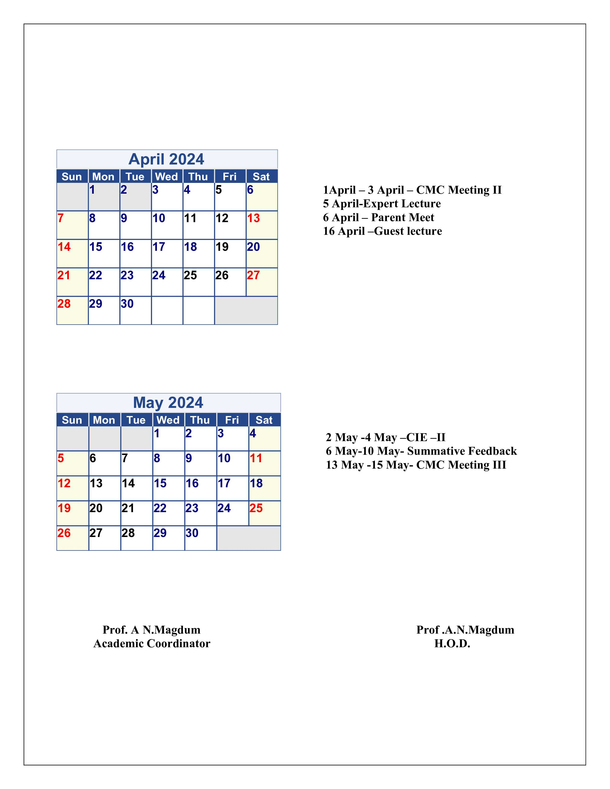

# DEPARTMENTAL TIME TABLE

Second Year Sem-I Time Table

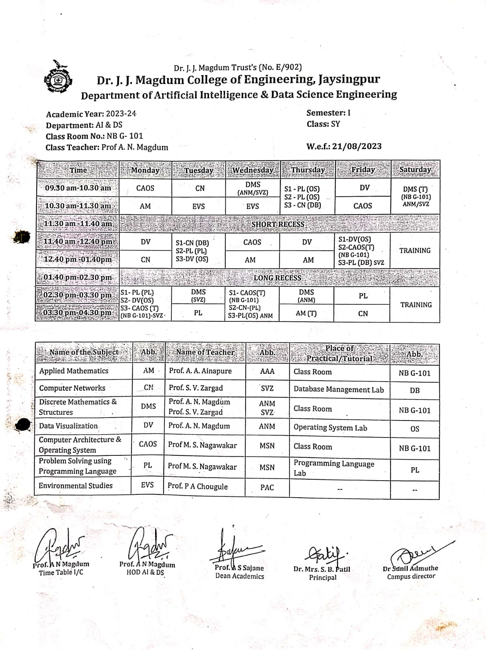





STRUCTURE OF SYLLABUS

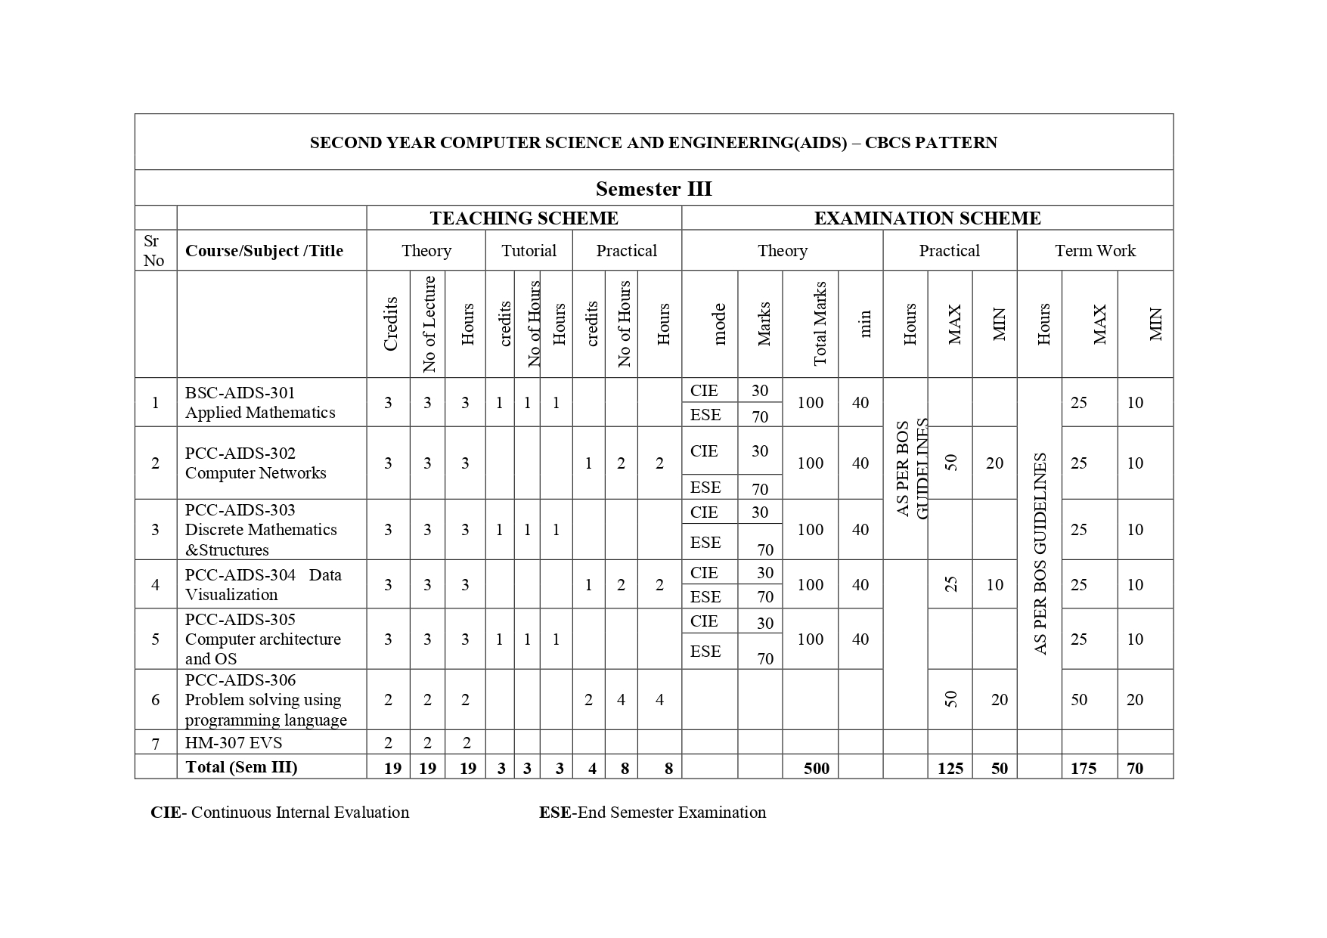

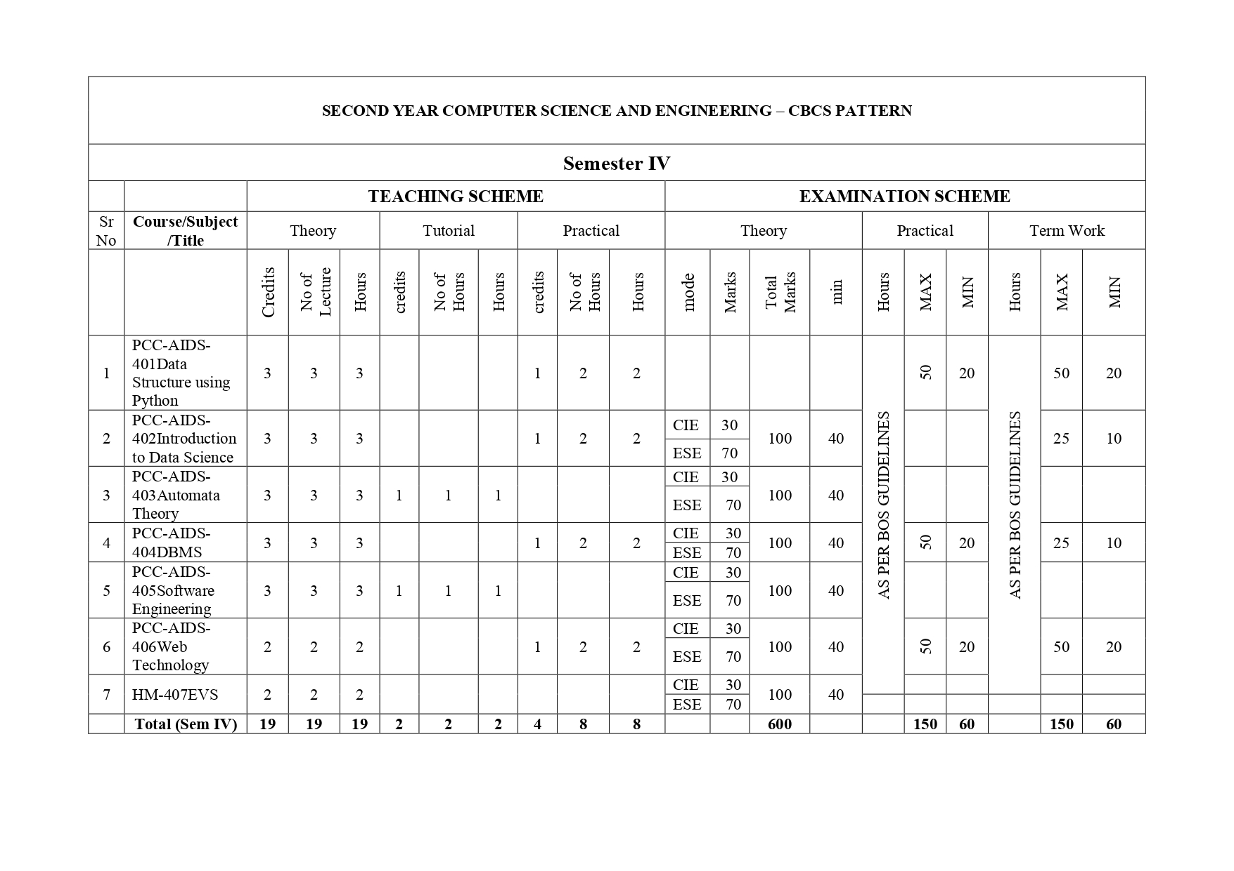



# COURSE DETAILS/SYLLABUS

#### S. Y. B. Tech (AIDS) Sem – III

**APPLIED MATHEMATICS**

|  |  |
| --- | --- |
| **TEACHING SCHEME** | **EXAMINATION SCHEME** |
| **Theory :** 3 Hrs / Week | **ESE:** 70  **CIE:** 30 |
| **Tutorial :** 1 Hrs / Week | **Term work:** 25 |
| **Practical:** | **Practical :** -- |

**Course Objectives:**

1. To develop mathematical skills and enhance thinking power of students.
2. To give the knowledge to the students of fuzzy set theory, numerical methods probability Linear algebra and statistics with an emphasis on the application of solving engineering problems
3. To prepare students to formulate a mathematical model using engineering skills & interpret the solution in real world.

**Course Outcomes:**

Upon successful completion of this course, the student will be able to:

1. Describe the statistical data numerically by using Lines of regression and Curve fittings.
2. Solve basic problems in probability theory, including problems involving the binomial, Poisson, and normal distributions.
3. Calculate numerical Integration.
4. Define fuzzy sets using linguistic words and represent these sets by membership functions, convexity, Normality, support, etc.
5. Solveexamples on vector calculus..
6. Solve assignment problems by using different techniques of operation research.

**SECTION – I**

**Unit 1. Correlation, Regression & Curve Fitting: 06**

1.1 Introduction.

1.2 Karl Pearson’s Coefficient of Correlation.

1.3 Lines of regression of bivariate data.

1.4 Fitting of Curves by method of Least-squares:

1.4.1 Fitting of Straight lines.

1.4.2 Fitting of exponential curves.

1.4.3 Fitting of second degree Parabolic curves.

**Unit 2. Probability Distribution: 06**

2.1 Random variables.

2.2 Discrete Probability distribution.

2.3 Continuous probability distribution.

2.4 Binomial Distribution.

2.5 Poisson Distribution.

2.6 Normal Distribution.

**Unit 3. Numerical Integration: 06**

3.1 Newton Cotes formulae.

3.2 Trapezoidal Rule.

3.3 Simpson's 1/3 rd rule.

3.4 Simpson's 3/8 th rule.

3.5 Weddle's Rule.

**SECTION – II**

**Unit 4. Introduction to Fuzzy sets: 06**

4.1 Crisp set and Fuzzy set.

4.2. Basic concepts of fuzzy sets.

4.3 Basic operations on fuzzy sets.

4.4 Properties of fuzzy sets.

4.5 Fuzzy Cardinality

4.6 Height of a fuzzy set , Normal and Subnormal fuzzy set

**Unit 5. Vector Calculus: 06**

5.1 1Introduction, Vectors in Rn.

5.2 , Vector Addition and Scalar Multiplication, Dot (Inner) Product, Located Vectors.

5.3 Hyper planes, Lines, Curves in Rn, Vectors in R3 (Spatial Vectors).

5.4 ijk Notation, Complex Numbers, Vectors in Cn..

**Unit 6. Assignment Problem: 06**

6.1 Definition, Balanced and Unbalanced assignment problem.

6.2 Hungarian Method.

6.3 Balanced assignment problems.

6.4 Unbalanced assignment problems.

**Reference Books:**

1. Linear Algebra, Seymour Lipschutz, Schaums outlines, 4th Edition, McGraw-Hill Publication

2. Introduction to Linear Algebra, Gilbert Strang, 5th Edition, Wellesley-Cambridge Press.

3. Higher Engineering Mathematics, by B. S. Grewal (Khanna Publication Delhi).

4. Advanced Engineering Mathematics, by H. K. Das (S. Chand Publication).

5. Fuzzy Sets and Fuzzy Logic: Theory and Applications, by George J. Klir and Bo Yuan (Prentice Hall of India Private Limited).

**General Instructions:**

1. For the term work of 25 marks, batch wise tutorials are to be conducted.
2. The number of students per batch per tutorial should be as per University rules.
3. Number of tutorials should be at least six (All units should be covered).

**COMPUTER NETWORK**

|  |  |
| --- | --- |
| **TEACHING SCHEME** | **EXAMINATION SCHEME** |
| **Theory :** 3 Hrs / Week | **ESE:** 70  **CIE:** 30 |
| **Tutorial : --** | **Term work:** 25 marks |
| **Practical:** 2 Hrs. /Week | **Practical :** 50 Marks |

**Prerequisite: Basic understanding of Computers**

**Course Outcomes:**

Upon successful completion of this course, the student will be able to –

1. Implement network and data link layer.

2. To implement the client server model using sockets.

3. To analyze the protocol structure using network analyzing tools.

4. Apply the concepts of application layer services.

5. Understand multimedia streaming and relevant protocols.

.

|  |  |  |
| --- | --- | --- |
| **Unit No.** | **Contents** |  |
| 1 | **Introduction to Computer Network: 6**  Overview of OSI layer Model and TCP/IP protocol model, Addressing, Underlying technologies for LANs, WANs, and Switched WANs |  |
| 2 | **Data Link Layer and Medium Access Control Sub layer 6**  Design issue**s** for Data Link Layers, Framing methods, Error control: detection and correction, Flow control, Elementary Data Link protocols, Static and Dynamic channel allocation, Multiple Access protocols, Ethernet: IEEE 802.3, IEEE 802.4, IEEE 802.5, 802.11 |  |
| 3 | **Network Layer and Internet Protocol 6** IPv4 Addresses, Sub-netting and Super netting, Class less Addressing, Delivery, Forwarding and routing; Routing methods, Congestion control algorithms: Principles, Congestion prevention policies, Load Shedding, Jitter Control, Datagram format, Fragmentation and reassembly models, ARP, RARP, ICMP, IGMP |  |
| 4 | **Transport Layer 6** UDP: Process to Process communication, User Datagram Format, Operation and uses of UDP. TCP: TCP Services and Features, TCP segment format, TCP Connections, Flow and error  control in TCP, TCP Timers; Berkeley Sockets: Socket Addresses, Elementary Socket system calls byte ordering and address conversion routines, connectionless  iterative server, connection oriented concurrent server, TCP and UDP Client server Programs. |  |
| 5 | **Application layer: DNS, FTP, Telnet 6** Domain Name Space, Distribution of name space, Resolution, DNS massages, BOOTP, DHCP Telnet Concept, NVT, Embedding, Options & options/sub-option negotiation, controlling  the server, Out-of-band signalling, Escape charter, Mode of operation, user interface. FTP: Connections, Communication, Command processing, File transfer, User interface, Anonymous FTP, TFTP. |  |
| 6 | **Web application and Multimedia Services 6**   HTTP: Architecture, Web Documents, HTTP Transaction, Request and Response, HTTP Headers and Examples Electronic Mail: SMTP commands and responses, Mail transfer phases, MIME, POP3 Multimedia In Internet:  Streaming stored audio/video, Streaming live audio/video, Real time interactive audio/video. |  |

**TEXT BOOKS:**

1. TCP/IP protocol suit 4thEd. – Behrouz A. Forouzen (Tata Mag.Hill)

2. Computer Networks – Andrew S. Tanenbaum(PHI)

3. Unix Network Programming – W. Richard Stevens (PHI)

**REFERENCEBOOKS:**

1. TCP/IP Illustrated, The Protocols, Vol. I – W. Richard Stevens, G. Gabrani (PearsonEducation.)

2. Internetworking with TCP/IP, Vol. I Principles, Protocols, and Architectures – D. E. Comer

(PearsonEd.)

3. Internetworking with TCP/IP, Vol. III, Client-Server Programming and Application (2nd Ed.) –D.E. Comer, David L. Stevens (Pearson Ed.)

**TERM WORK**

1. Study, design and configuration of IEEE 802.3 Ethernet and IEEE 802.11Wireless LANs (ReferringRFCs)

2. Study of following connectivity test tools with all its options– ifconfig, arp route, traceroute nmap, netstat, finger.

3. Implementing Framing methods

4. Implementation of Error detection code CRC and Hamming code

5. Programs to understand IP addressing, classful & classless addressing

6. Implement shortest path routing algorithm.

7. Client program using UDP to connect to well known services (echo, time of the day service etc.).

8. Implementing concurrent TCP multi service client/server.

9. Study of network protocol analyzer (Ethereal or Wire-Shark) and understanding packet

formats for UDP, TCP, ARP, ICMP protocols.

10. Study of following DNS Tools with all its options. nslookup, dig, host,whois.

11. Configuration of basic services for FTP, HTTP, Telnet etc. on Linux Platform

12. Write program to send a mail using SMTP commands and receive a mail using POP3commands.

## DISCRETE MATHEMATICS STRUCTURE

|  |  |
| --- | --- |
| **TEACHING SCHEME** | **EXAMINATION SCHEME** |
| **Theory :** 3 Hrs/Week | **ESE:** 70 **CIE**: 30 |
| **Tutorial :** 1 Hrs/Week | **Term work:** 25 marks |
| **Practical:** --- | **Practical :---** |

**Prerequisite:** Basic Mathematics

### Course Objectives:

* 1. To expose the students to the mathematical logic related to computer science areas.
  2. To enhance the problem solving skills in the areas of theoretical computer science.
  3. To use mathematical concepts in the development of computer applications.

### Course Outcomes:

Upon successful completion of this course, the student will be able to –

1. Apply logic concepts in designing program.
2. Illustrate basic set concepts & apply operations onset.
3. Minimize the Boolean Function.
4. Apply basic concepts of probability to solve real world problem.
5. Represent data structures using graph concepts.
6. Design abstract machine, detect deadlocks.

|  |  |  |
| --- | --- | --- |
| **Unit** | **Contents** | **No. of** |
| **No.**  1 | **Mathematical Logic:** | **Lectures**  10 |
|  | Statements & Notations, Connectives, Statement Formulas & truth table, Well |  |
|  | formed formulas, Tautologies , Equivalence of formulas, Duality law, Tautological |  |
|  | Implications, Functionally complete set of connectives, Other connectives, Normal |  |
|  | Forms, Theory of Inference for statement calculus. |  |
| 2 | **Set Theory:**  Basic concepts of set theory, Operations on Sets, Ordered pairs & n-tuples, Cartesian | 04 |
|  | product |  |
| 3 | **Relations & Functions:** | 06 |
|  | Relations. Properties of binary relations. Matrix & Graph Representation of |  |
|  | Relation., Partition & covering of Set, Equivalence Relations. , Composition of |  |
|  | Binary Relation., POSET & Hasse Diagram, Functions, Types of Functions, |  |
|  | Composition of functions.. |  |

|  |  |
| --- | --- |
| 4 **Algebraic Systems:** | 06 |
| Algebraic Systems: Examples & general Properties, Semi groups & Monoids, Groups: |  |
| Definitions & Examples, Subgroup & Homomorphism. |  |
| 5 **Lattice and Boolean Algebra:**  Lattice as partially ordered sets, Lattice as Algebraic Systems., Special Lattices., Boolean | 08 |
| Algebra: Definitions & examples, Boolean Functions., Representation & Minimization of |  |
| Boolean Functions. |  |
| 6 **Graph Theory:** | 05 |
| Basic concepts of graph theory., Paths, Reachability & Connectedness, Matrix, |  |
| Representations of Graphs., Storage Representation & Manipulations of Graphs. |  |
| PERT & Related technologies. |  |

### Text Books:

1.DiscreteMathematicalStructureswithApplicationtoComputerScience”byJ.P.Tremblay & R. Manohar (MGH International)

### Reference Books:

1. Discrete Mathematics –SemyourLipschutz, Marc Lipson (MGH), Schaum’s outlines.
2. Discrete Mathematics and its Applications – Kenneth H. Rosen (AT&T Bell Labs) (mhhe.com/rosen)
3. Discrete Mathematical Structures – Bernard Kolman, Robert Busby, S. C. Ross and Nadeemur- Rehman (PearsonEducation)

### TERM WORK :

It should consist of minimum 10 to 12 assignments based on topics of syllabus & Exercise problems mentioned in text books out of which 4 to 5 implementations of above assignments must be using ‘C’ programming language.

**DATA VISUALIZATION**

|  |  |
| --- | --- |
| **TEACHING SCHEME** | **EXAMINATION SCHEME** |
| **Theory :** 3 Hrs/Week | **ESE:** 70 **CIE**: 30 |
| **Tutorial : --** | **Term work:** 25 |
| **Practical:** 2 Hr / Week | **Practical :** 25 |

|  |  |
| --- | --- |
| **Unit** | **Content** |
| **1** | **Introduction to Data Visualization 6**  Brief history of data visualization, scientific design choices in data visualization- choice of graphical form, grammar of graphical techniques of large amount of data, crucial need of visualization techniques, challenges in visualization techniques, classification of visualization techniques for qualitative and quantitative data, power of visualization techniques, introduction to different visualization techniques. |
| **2** | **Static Graphical Techniques – 1 6**  Introduction to bar graph, basic understanding of making basic bar graph, grouping bars together, bar graphs on counts, customization of bar graphs by changing application of bar graph in business. |
| **3** | **Multivariate Graphical Techniques 6**  Introduction to correlation matrix, application of correlation matrix in the multivariate analysis, network graph, basics of heat map, difference between heat map and tree map, introduction to higher dimensional scatter plot, axis adjustment in the higher dimensional scatter plot, addition of prediction surface of higher dimensional scatter plot. |
| **4** | **Graphical Validation 6**  Basics of multivariate statistical visual representations and its results, dendrogram, importance of dendrogram in grouping (cluster analysis), Scree Plot, importance of Scree Plot, application of Scree Plot in determining number of clusters and factors, QQ plot, importance of QQ plot in distribution of data for the further quantitative analysis, PP plot, applications and usage of PP Plot for distribution detection. |
| **5**  **6** | **Customization - I 6**  Introduction to annotations – adding : text, mathematical expression , lines, arrows, shaded shapes, highlighting the texts and items, adding error bars, introduction to axis, swapping x and y axis, changing the scaling ration in the axis, positioning of axis and arranging tick marks and labels,  colour, size, title, axis units, changing width and spacing of the bar chart, adding labels to bar graph,  **Customization - II 6**  Changing the appearance of axis labels, circular graphs, using themes, changing the appearance of theme elements, creating the own themes, legends : removing the legends, position of legends, legend title, labels in legends. |

**Text Books:**

1. Data Visualization: Principles & Practices, Alexandru Telea, 2nd Ed, CRC Press
2. Hand Book of Data Visualization, Chun-houh Chen, Wolfgang Härdle, Antony Unwin, Springer Publication

**Reference Books:**

|  |  |  |  |
| --- | --- | --- | --- |
| **1.** | R Graphics Cook Book | Winston Chang | First Edition, O’Reilly Publication |
| **2.** | ggplot2 Elegant Graphics for Data Analysis | Hadley Wickham | Springer Publication |

# **COMPUTER ARCHITECTURE & OPERATING SYSTEM**

|  |  |
| --- | --- |
| **TEACHING SCHEME** | **EXAMINATION SCHEME** |
| **Theory :** 3 Hrs / Week | **ESE : 70 CIE**: 30 |
| **Tutorial : ---** 1 Hr / Week | **Term work:** 25 |
| **Practical: --** | **Practical :**  -- |

## Pre-Requisites: None

**Course Objectives:**

After completion of the course, students will have adequate background, conceptual clarity and knowledge of appropriate solution techniques related to:

1. To understand the structure, function and characteristics of computer systems
2. To identify the elements of modern instructions sets and their impact on processor design
3. To understand the services provided by and the design of an operating system.
4. Understand the structure, organization memory management.

## **Course Outcomes:**

On completion **of** the course, students will be able to:

|  |  |
| --- | --- |
| 1. | Understand the theory and architecture of central processing unit & Analyze some of the design issues in terms of speed, technology, cost, performance |
| 2. | Use appropriate tools to design verify and test the CPU architecture & Learn the concepts of parallel processing, pipelining and inter processor communication. |
| 3. | Understand the architecture and functionality of central processing unit & Exemplify in a better way the I/O and memory organization, Memory management systems, Virtual Memory |
| 4. | Describe and explain the fundamental components of a computer operating system |
| 5. | Define, restate, discuss, and explain the policies for scheduling, deadlocks, memory management, synchronization, system calls, and file systems. |

## Course Contents:

**1: Introduction, Arithmetic and Instruction Sets 6**

**Introduction:** Concept of computer organization and architecture, Fundamental unit, Computer function and interconnection, CPU structure and function.

**Computer Arithmetic:** The arithmetic and logic Unit, Integer representation, Integer arithmetic, Floating point representation, Floating point arithmetic, Introduction of arithmetic co-processor.

**Instruction Sets:** Characteristics, Types of operands, Types of operations, Assembly language, Addressing modes, Instruction format, Types of instruction, Instruction execution, Machine state and processor status, Structure of program, Introduction to RISC and CISC architecture.

**2: Memory Organization and Management 8**

**Memory Organization:** Internal Memory: Semiconductor main memory, Error correction, Advanced DRAM organization, Virtual memory systems and cache memory systems. External Memory: Organization and characteristics of magnetic disk, Magnetic tape, Optical memory, RAID, Memory controllers.

**Memory Management:** Basic concept, Logical and Physical address map, Memory allocation: Continuous Memory Allocation, Fixed and variable partition, Internal and external fragmentation and compaction, Paging: Principle of operation, Page allocation – Hardware support for paging, Protection and sharing, Disadvantages of paging.

**Virtual Memory:** Basics of Virtual Memory – Hardware and control structures – Locality of reference, Page fault, Working Set, Dirty page/Dirty bit – Demand paging, Page Replacement algorithms: Optimal, First in First Out (FIFO), Second Chance (SC), Not recently used (NRU) and Least Recently used (LRU).

## **3: Control Unit & Input/ Output Organization**: 6

**Control Unit: Control unit operation:** Micro-operations, Control of the processor, Hardwired implementation, Micro-programmed Control Unit, Basic concepts, Micro-instruction sequencing, Micro-instruction execution, Applications of micro-programming.

**Input/ Output Organization:** External devices, I/O module, Programmed I/O, Interrupt driven I/ O, Direct memory access, I/O channels and processors, External interface. Instruction pipe-lining: Concepts. Parallel processing: Multiple processor organization, Symmetric multiprocessor, Cache coherence and the MESI protocol.

**4: Introduction OS & Processes and CPU Scheduling: 6**

**Introduction and Operating system structures:** Definition, Types of Operating system, Real Time operating system, System Components- System Services, Systems Calls, System Programs, System structure. Virtual Machines, System Design and Implementation, System Generations.

**5: Processes and CPU Scheduling 6**

**Processes and CPU Scheduling:** Process Concept, Process Scheduling, Operation on process, Cooperating processes. Threads, Inter-process Communication, Scheduling criteria, scheduling Algorithms, Multiple-Processor Scheduling, Real-Time Scheduling, Scheduling Algorithms and performance evaluation.

**6: Process Synchronization & Deadlocks 6**

**Process Synchronization**: The critical-section problem, Critical regions, Synchronization Hardware, Semaphores, Classical Problems of synchronization, and Monitors Synchronizations in Solaris.

**Deadlocks:** Systems Model, Deadlock characterization, Methods for handling Deadlocks, Deadlock Prevention, Deadlock Avoidance, Deadlock Detection, Recovery from Deadlock, Combined approach to deadlock Handling.

## Text Books

* 1. William Stalling, Computer Organization and Architecture: Designing for Performance, Prentice Hall Publication, 8th Edition, 2009.
  2. Hayes, Computer Architecture and Organization, McGraw-Hill Publication, 3rd Edition, 2012.
  3. Zaky, Computer Organization, McGraw-Hill Publication, 5th Edition, 2011
  4. Andrew S. Tanenbaum, Modern Operating System, PHI Publication, 4th Edition, 2015.

## Reference Books

1. Hennessy and Patterson, Computer Architecture: A Quantitative Approach, Morgan and Kaufman Publication, 4th Edition, 2007.
2. Morris Mano, Computer System Architecture, Pearson Education India, 3rd Edition, 2007.
3. Mostafa Abd-El-Barr, Hesham El-Rewini, Fundamentals of Computer Organization and Architecture, Wiley Publication, 1st Edition, 2004.

**PROBLEM SOLVING USING PROGRAMMING LANGUAGES**

|  |  |
| --- | --- |
| **TEACHING SCHEME** | **EXAMINATION SCHEME** |
| **Theory :** 3 Hrs / Week | **Theory :**--- |
| **Tutorial : ---** | **Term work:** 50 |
| **Practical:** 4 Hrs. / Week | **Practical :** 50 |

**Prerequisite:** Digital Electronics, Computer Fundamentals

### Course Objectives:

1. To learn concepts of arrays and pointers in C
2. To learn file handling in C
3. To learn memory management in C
4. To learn structures in C

### Course Outcomes:

Upon successful completion of this course, the student will be able to –

1. Articulate the principles of procedure oriented problem solving and programming.
2. Explain programming fundamentals including statements, control flow and recursion
3. Able to formulate problems and implement algorithmic . .
4. Analyze and use data structures to solve the complex problem statements. .
5. Demonstrate file operations using file handling concepts through developing applications.

### Unit No.

**Contents No. of**

### Lectures

1. **Introduction to C:**

The Form of a C Program, The Library and Linking, Separate Compilation, Compiling 6 C Program, C's Memory Map; Expressions – The Basic Data Types, Modifying the Basic Types, Identifies Names, Variables, The Four C Scopes, Type Qualifiers-const, volatile, Storage Class Specifiers; Statements - Selection Statements, Iteration

Statements, Jump Statements, Expression Statements, Block Statements.

### Console I/O & Basics of Array and Strings. 6

Console I/O: Reading and Writing Characters, Reading and Writing Strings, Formatted Console I/O, printf(), scanf(), Suppressing Input. Arrays and Strings- Two-Dimensional Arrays, Arrays of Strings, Multidimensional Arrays, Array Initialization, Variable- Length Arrays.

### Functions: 6

The General Form of a Function, Understanding the Scope of a Function, Parameter passing, Passing arrays to functions, Function Arguments, argc and argv-Arguments to main(),The return Statement, What Does main( ) Return?,

Recursion, Function Prototypes, Declaring Variable Length Parameter

Lists, The inline Keyword.

4. **Pointers: 6**

What Are Pointers?, Pointer Variables, The Pointer 0perators, Pointer Expressions, Pointers and Arrays, Arrays of Pointers, Multiple Indirection, Initializing Pointers, Pointers to Functions and structures, C's Dynamic Allocation Functions, restrict-Qualified Pointers, Problems with Pointers.

**5 Introduction to Python: 6**

Introduction, History of Python, Introduction to Python Interpreter and program

execution, Python Installation Process in Windows and Linux, Python IDE,

Introduction to anaconda, python variable declaration, Keywords, Indents in Python,

Python input/output operations

**6. Python’s Operators & Built in Types 6**

Arithmetic Operators, Comparison Operators, Assignment Operators, Logical

Operators, Bitwise Operators, Membership Operators, Identity Operators, Ternary

Operator, Operator Precedence, Python’s Built-in Data types String, List, Tuple, Set,

Dictionary (characteristics and methods)

### TEXT BOOKS:

1. C the Complete Reference by Herbert Schild (Tata McGraw Hill) 4thEdition.
2. The C Programming Language- Brian W. Kernighan, Dennis Ritchie 2ndEdition.
3. Mark Lutz, “Learning Python”, 5th edition, Orelly Publication,
4. Michel Dawson, “Python Programming for Absolute Beginers” ,

### REFERENCE BOOKS:

1.Programming in ANSI C by E.Balaguruswamy.(TataMcGraw Hill) 4th Edition.

2. David Beazley, Brian Jones., “Python Cookbook”, Third Edition, Orelly Publication

## **ENVIORMENT STUDIES (For Sem III & IV)**

|  |  |
| --- | --- |
| **TEACHING SCHEME** | **EXAMINATION SCHEME** |
| **Theory : 2 Hrs/Week** | ESE (For 4th Sem) – 70marks |
| **Tutorial :--** | (For 4th Sem) Environmental Project Report 30 marks |

# 1. Nature of Environmental Studies: 3

Definition, scope and importance. Multidisciplinary nature of environmental studies Need for public awareness. Concept of sustainability. Sustainable development and it’s goals with Indian context.

# 2. Ecosystems: 9

Concept of an ecosystem, Structure and function of an ecosystem. Producers, consumers and decomposers. Energy flow in the ecosystem, Ecological succession.

Food chains, food webs and ecological pyramids, Introduction, types, characteristics features, structure and function of the following ecosystem:-

Forest ecosystem, b) Grassland ecosystem, c) Desert ecosystem, d)Aquatic ecosystems (ponds, streams, lakes, rivers, oceans, estuaries) Degradation of the ecosystems and it’s impacts.

# 3. Natural Resources and Associated Problems: 8

**Forest resources:** Use and over-exploitation, deforestation, dams and their effects on forests and tribal people.

**Water resources:** Use and over-utilization of surface and ground water, floods, drought, conflicts over water, dams-benefits and problems.

Mineral resources: Usage and exploitation. Environmental effects of extracting and using mineral resources.

**Food resources:** World food problem, changes caused by agriculture, effect of modern agriculture, fertilizer-pesticide problems.

**Energy resources:** Growing energy needs, renewable and non- renewable energy resources, use of alternate energy sources. Solar energy , Biomass energy, Nuclear energy,

**Land resources:** Land as a resource, land degradation, man induced landslides, soil erosion and desertification. Consumerism, ecological foot prints, carbon foot prints, carbon credits.

Role of an individuals in conservation of natural resources. Equitable use of resources for sustainable lifestyles.

# 4. Biodiversity and its Conservation: 8

Introduction- Definition: genetic, species and ecosystem diversity.

Bio-geographical classification of India.

Value of biodiversity: consumptive use, productive use, social, ethical, aesthetic and option values., India as a mega- diversity nation, Western Ghat as a biodiversity region, Hot-spots of biodiversity, Threats to biodiversity: habitat loss, poaching of wildlife, man- wildlife conflicts, Endangered and endemic species of India,

Conservation of biodiversity: In-situ and Ex- situ conservation of biodiversity. Convention on Biological Diversity.

# 5. Environmental Pollution: 8

Definition: Causes, effects and control measures of:

Air pollution, Water pollution, Soil pollution, Marine pollution Noise pollution

Thermal pollution, Nuclear hazards, Global Level Environmental Problems like Global warming, acid rain, ozone layer depletion, Nuclear accidents and holocaust.

Solid waste Management: Causes, effects and control measures of urban and industrial wastes. Solid waste management control rules, Role of an individual in prevention of pollution.

**Unit 6. Social Issues and the Environment: 9**

Human population growth, impact on environment.Human Health and welfare, Environmental ethics: Role of Indian religious traditions and culture in conservation of the environment.

Environmental movements- Chipko Movement, Appiko Movement, Silent Valley. Resettlement and rehabilitation of people; its problems and concerns.

Water conservation, rain water harvesting, watershed management. Water conservation by Dr.Rajendra Singh, Anna Hazare etc.

Disaster management: floods, earthquake, cyclone, tsunami and landslides. Wasteland reclamation, Environmental communication and public awareness, case studies.

# 7. Environmental Protection- Policies and practices: 5

Environmental Protection Act.1986

Air (Prevention and Control of Pollution) Act.1981

Water (Prevention and control of Pollution) Act - 1974

Wildlife Protection Act-1972

Forest Conservation Act-1980

National and International conventions and agreements on environment

# 8. Field Work (Environmental Project Report) 10

Visit to a local area to document environmental assets-

River/forest/grassland/hill/mountain, or Visit to a local polluted ite/Industry, or Urban/Rural/Industrial/Agricultural or Study of common plants, insects, birds.or Study of simple ecosystems - ponds, river, hill slopes, etc. (Field work is equal to 10 lecture hours)

# References:

Agarwal, K.C.2001, Environmental Biology, Nidi Pubi. Ltd., Bikaner.

Bharucha Erach, The Biodiversity of India, Mapin Publishing pvt. Ltd.,Ahmedabad 380013, India, [Email:mapin@icenet.net](mailto:mapin@icenet.net) (R)

Brunner R.C.,1989, Hazardous Waste Incineration, McGraw Hill Inc., 480p

Clank R.S. Marine Pollution, Clanderson Press Oxford (TB)

Cunningham, W.P. Cooper, T.H.Gorhani, E. & Hepworth, M.T.2001,

Environmental Encyclopedia, Jaico Publ. Hpise, Mumbai, 1196p

De A.K., Environmental Chemistry, Wiley Western Ltd.

Down to Earth , Cebtre fir Scuebce and Environment (R)

Gleick, H.,1993, Water in crisis, Pacific Institute for studies in Dev. Environment & Security. Stockholm Env. Institute. Oxford Univ. Press 473p

Hawkins R.e., Encyclopedia of Indian Natural History, Bombay Natural History Society, Bombay (R)

Heywood, V.H.& Watson, R.T.1995, Global Biodiversity Assessment,Cambridge Univ. Press 1140p.

Jadhav, H.& Bhosale, V.M.1995, Environmental Protection and Laws, Himalaya Pub. Hcuse, Delhi 284p.

Mickinney, M.L.& School. R.M.1196, Environmental Science Systems & Solutions, Web enhanced edition, 639p.

Mhaskar A.K., Mastter Hazardous, Techno-Science Publications (TB)

Miller T.G.Jr., Environmental Science. Wadsworth Publications Co. (TB)

Odum, E.P.1971, Fundamentals of Ecology, W.B.Saunders Co. USA, 574p.

Rao M.N.& Datta, A.K.1987, Waste Water Treatment, Oxford & IBH Publ. Co. Pvt. Ltd., 345p

Sharma B.K., 2001, Environmental Chemistry, Gokel Publ. Hkouse, Meerut

Survey of the Environment, The Hindu (M)

Townsend C., Harper, J. and Michael Begon, Essentials of Ecology, Blackwell Science (TB)

Trivedi R.K. Handbook of Environmental Laws, Rules, Guidelines, Compliances and Standards, vol. I anfd II, Environmental Media (R)

Trivedi R.K. and P.K. Gokel, Intriduction to air pollution, Tecgbi-Science Publications (TB)

Wagner K.D.,1998, Environmental management, W.B. Saunders Co.Philadelphia, USA 499p.

Paryavaran shastra – Gholap T.N.

Paryavaran Sahastra – Gharapure

M) Magazine (R) Reference (TB) Textbook



# TEACHING PLAN

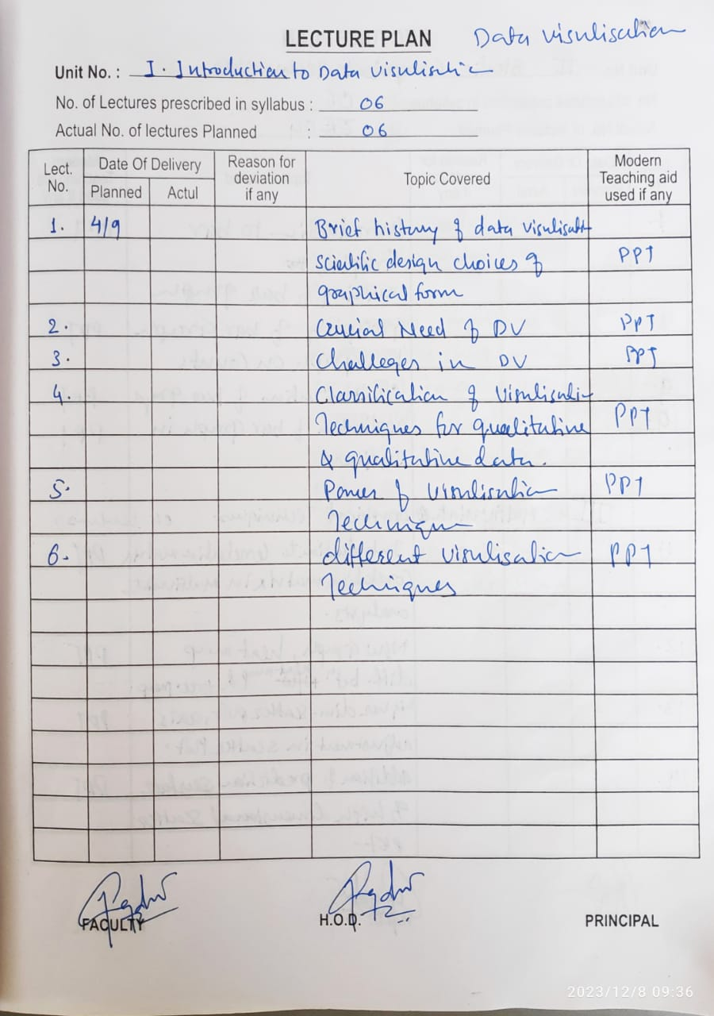

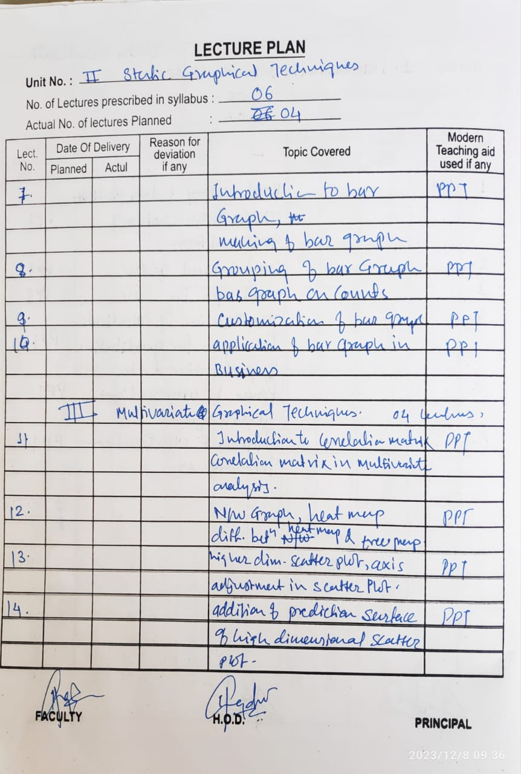

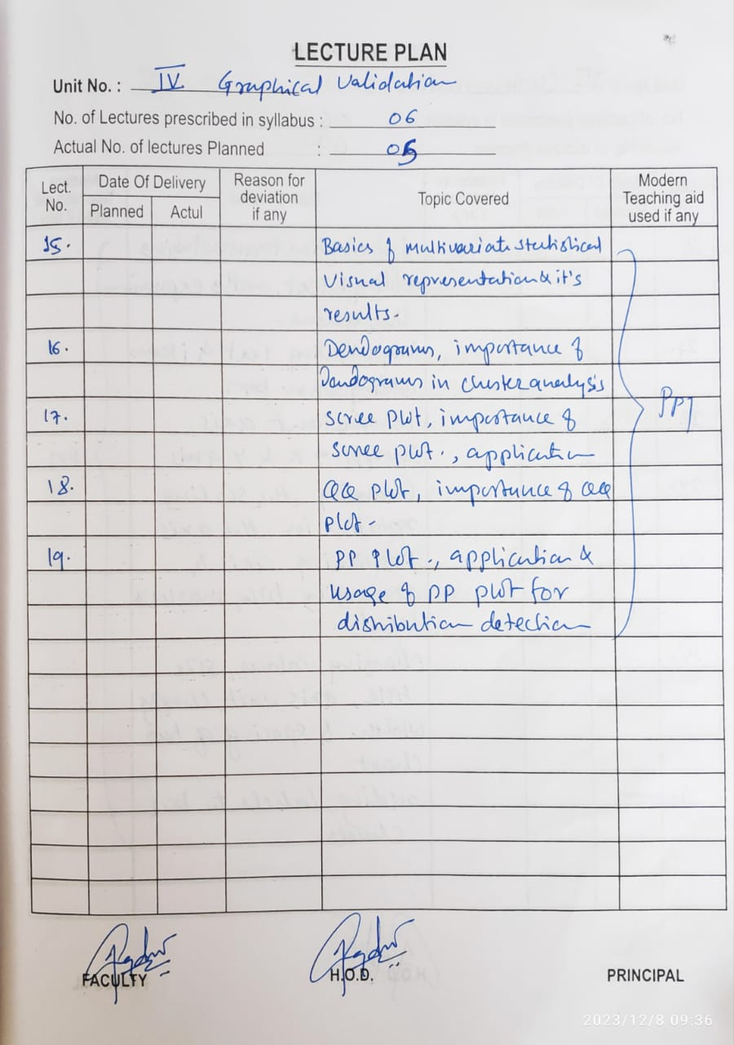

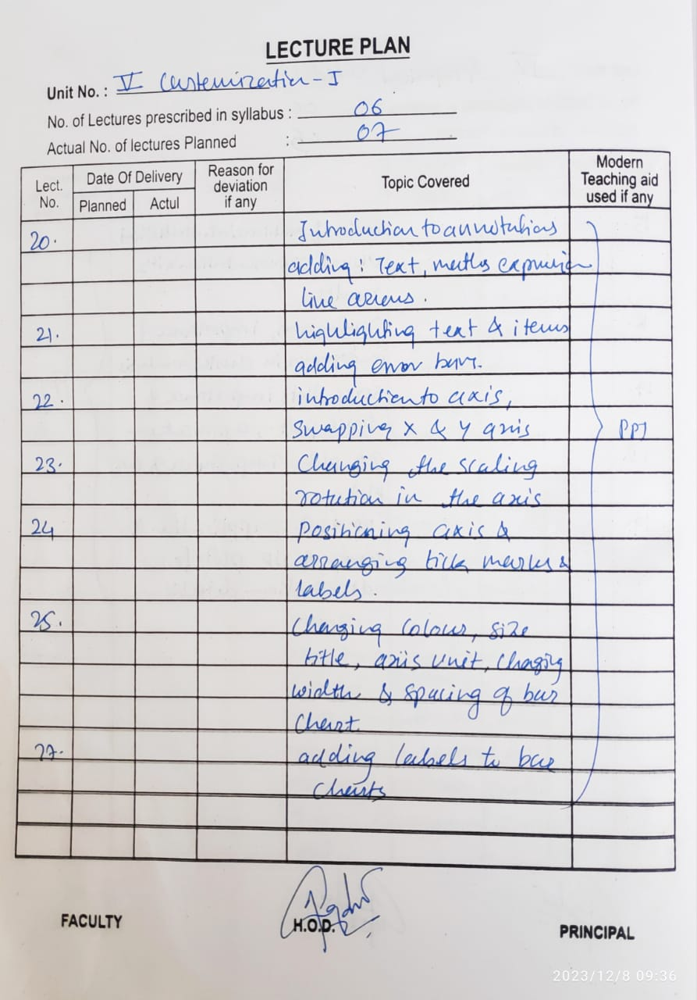

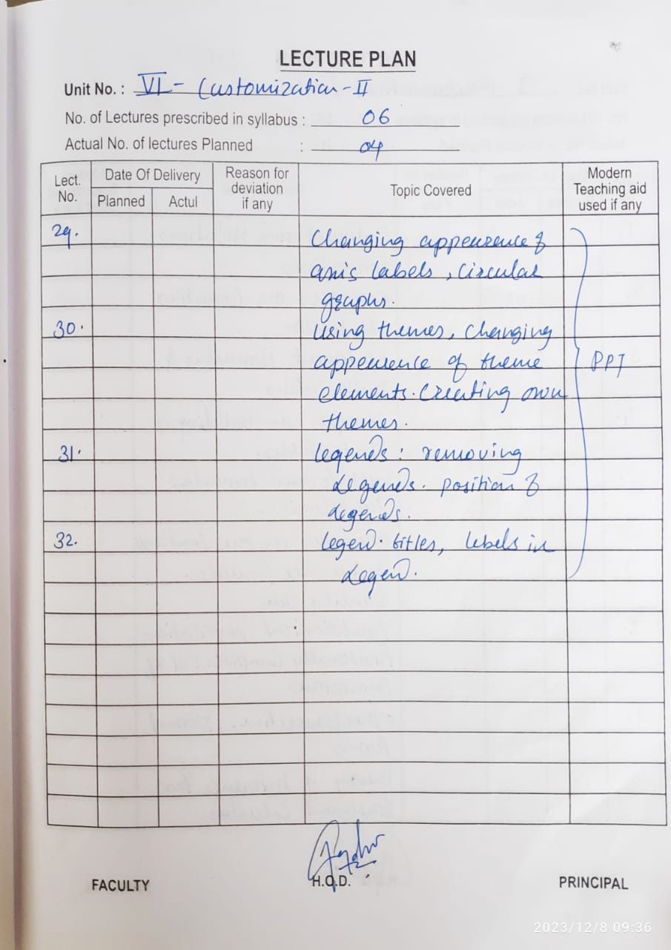

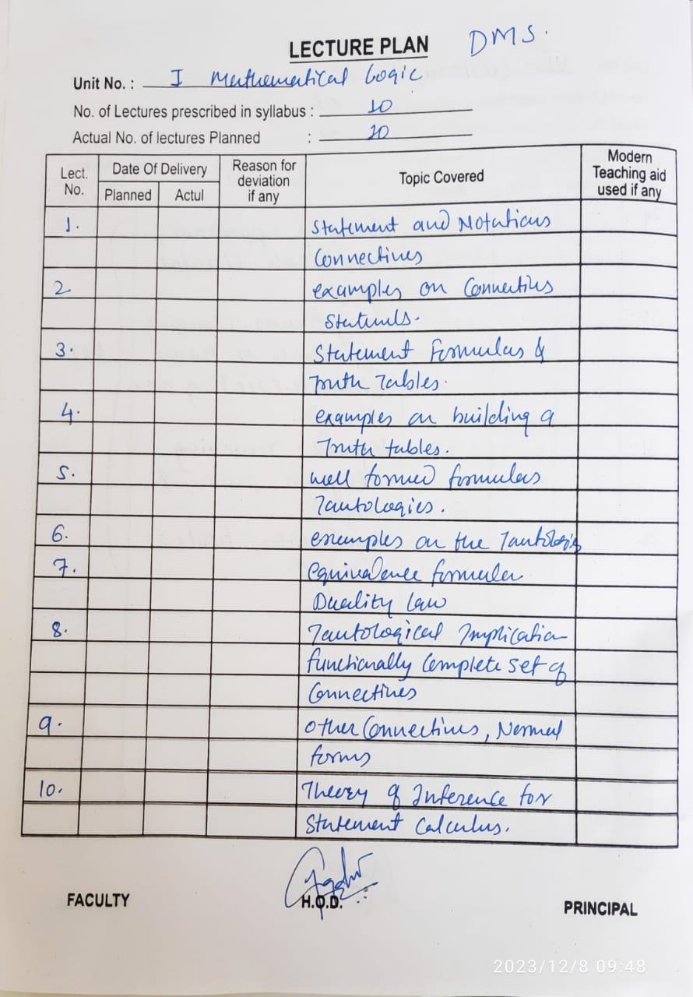

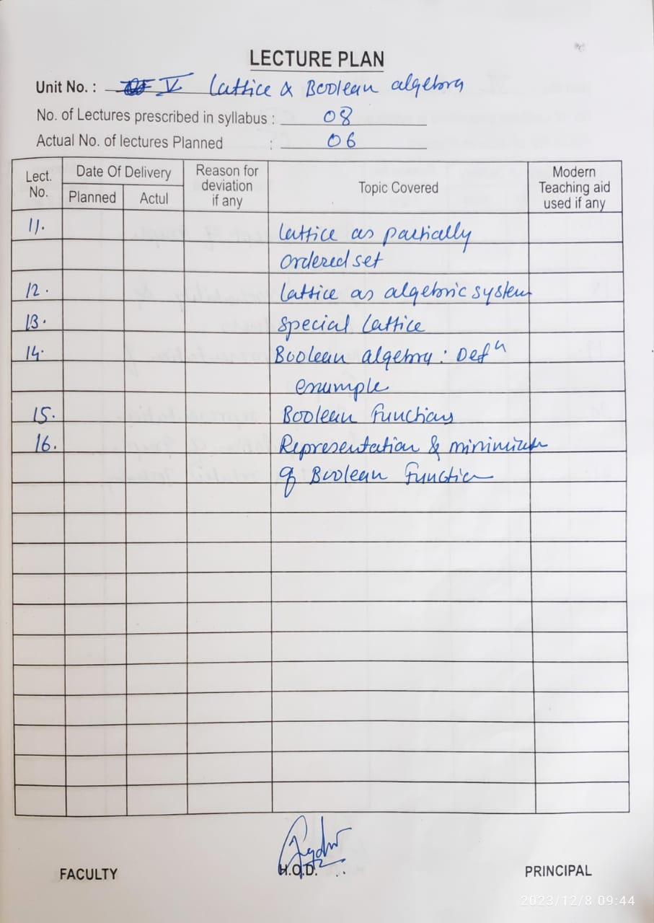

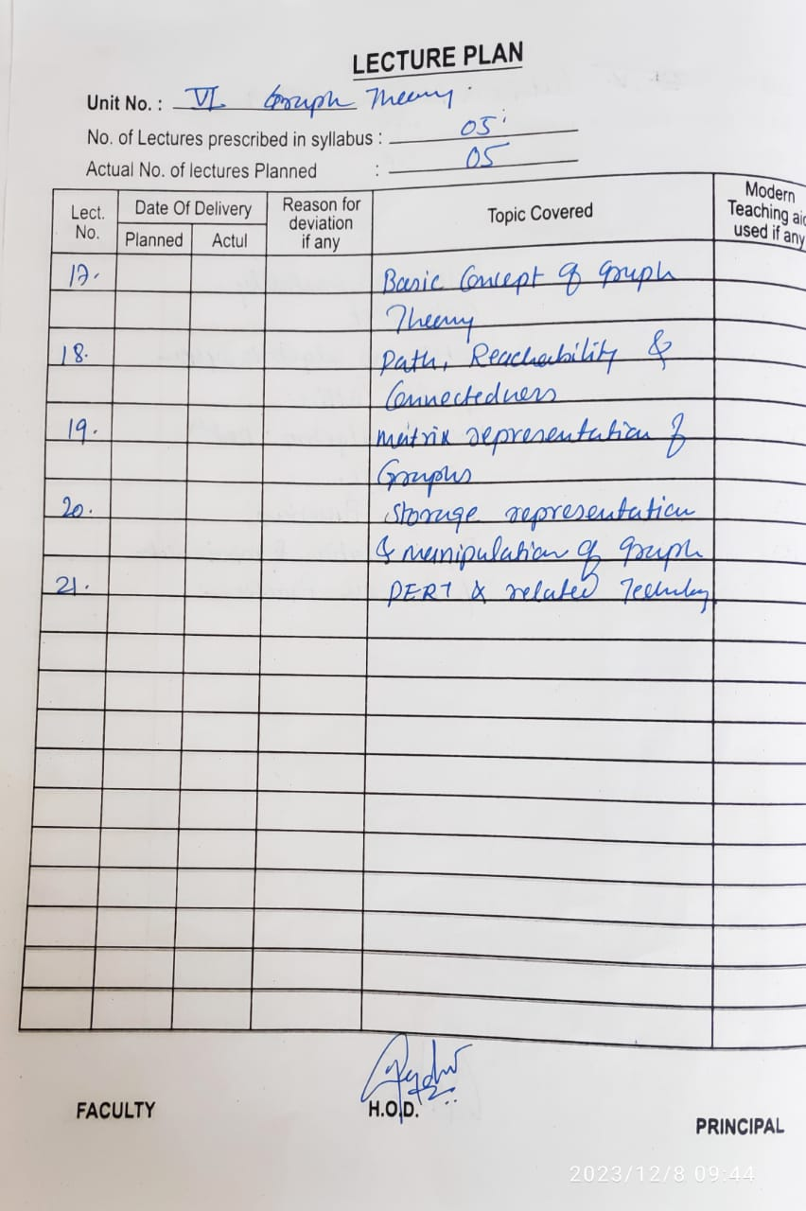

|  |  |  |
| --- | --- | --- |
| Dept of Artificial Intelligence & Data Science (SY B-Tech Sem I 2023-24)Lecture Plan: C N | | |
| **UNIT**  **No.** | **Lect.**  **No.** | Details of syllabus planned |
| 01 | **Introduction to Computer Network** | |
| 1 | Overview of OSI layer Model |
| 2 | TCP/IP protocol model |
| 3 | Addressing |
| 4 | Underlying technologies for LANs |
| 5 | Underlying technologies for WANs |
| 6 | Switched WANs |
| 02 | **Data Link Layer and Medium Access Control Sub layer** | |
| 1 | Design issues for Data Link Layers, Framing methods |
| 2 | Error control: detection and correction, Flow control |
| 3 | Elementary Data Link protocols |
| 4 | Static and Dynamic channel allocation |
| 5 | Multiple Access protocols, Ethernet: IEEE 802.3 |
| 6 | IEEE 802.4, IEEE 802.5, 802.11 |
| 03 | **Network Layer and Internet Protocol** | |
| 1 | IPv4 Addresses, Sub-netting and Super netting |
| 2 | Class less Addressing, Delivery, Forwarding and routing |
| 3 | Routing methods |
| 4 | Congestion control algorithms: Principles, Congestion prevention policies |
| 5 | Load Shedding, Jitter Control |
| 6 | IP Datagram format, Fragmentation and reassembly models |
| 7 | ARP, RARP, ICMP, IGMP |
| 04 | **Transport Layer** | |
| 1 | UDP: Process to Process communication, User Datagram Format, Operation and uses of UDP. |
| 2 | TCP: TCP Services and Features, TCP segment format, TCP Connections |
| 3 | Flow and error control in TCP,TCP Timers |
| 4 | Berkeley Sockets: Socket Addresses |
| 5 | Elementary Socket system calls byte ordering and address conversion routines |
| 6 | Connectionless iterative server, connection oriented concurrent server |
| 7 | TCP and UDP Client server Programs |

|  |  |  |
| --- | --- | --- |
| **UNIT**  **No.** | **Lect.**  **No.** | Details of syllabus planned |
| 05 | Application Layer: DNS, FTP, Telnet | |
| 1 | Domain Name Space, Distribution of name space |
| 2 | Resolution, DNS massages |
| 3 | BOOTP, DHCP Telnet Concept, NVT |
| 4 | Embedding, Options & options/sub-option negotiation, controlling the server |
| 5 | Out-of-band signalling, Escape charter, Mode of operation, user interface |
| 6 | FTP: Connections, Communication, Command processing, File transfer, User interface, Anonymous FTP, TFTP |
| 06 | Web Applications and Multimedia Services | |
| 1 | HTTP: Architecture, Web Documents, HTTP Transaction, Request and Response |
| 2 | HTTP Headers and Examples |
| 3 | Electronic Mail, SMTP, commands and responses |
| 4 | Mail transfer phases, MIME, POP3 |
| 5 | Multimedia In Internet: Streaming stored audio/video, Streaming live audio/video |
| 6 | Real time interactive audio/video |

|  |  |  |
| --- | --- | --- |
| Dept of Artificial Intelligence & Data Science (SY B-Tech Sem I 2023-24)Discrete Mathematics Structure | | |
| **UNIT**  **No.** | **Lect.**  **No.** | Details of syllabus planned |
| 02 | **Set Theory** | |
| 1 | Basic concepts of set theory |
| 2 | Operations on Sets |
| 3 | Operations on Sets |
| 4 | Ordered pairs & n-tuples |
| 5 | Cartesian product |
| 03 | **Relations & Functions** | |
| 1 | Relations. Properties of binary relations |
| 2 | Relations. Properties of binary relations |
| 3 | Matrix & Graph Representation of Relation |
| 4 | Partition & covering of Set, Equivalence Relations |
| 5 | Partition & covering of Set, Equivalence Relations |
| 6 | Composition of Binary Relation |
| 7 | POSET & Hasse Diagram |
| 8 | Functions, Types of Functions, Composition of functions |
| 04 | **Algebraic Systems:** | |
| 1 | Algebraic Systems: Examples & general Properties, |
| 2 | Semi groups & Monoids |
| 3 | Semi groups & Monoids |
| 4 | Groups:Definitions & Examples |
| 5 | Subgroup & Homomorphism |
| 6 | Subgroup & Homomorphism |

|  |  |  |
| --- | --- | --- |
| Dept of Artificial Intelligence & Data Science (SY B-Tech Sem I 2023-24)Lecture Plan: C Programming | | |
| **UNIT**  **No.** | **Lect.**  **No.** | Details of syllabus planned |
| 01 | **1: Introduction, Arithmetic and Instruction Sets** : | |
| 1 | Concept of computer organization and architecture, Fundamental unit |
| 2 | Computer function and interconnection, CPU structure and function |
| 3 | The arithmetic and logic Unit, Integer representation, Integer arithmetic, |
| 4 | Floating point representation, Floating point arithmetic, Introduction of arithmetic co-processor |
| 5 | InstructionSets**:** Characteristics, Types of operands, Types of operations, Assembly language, Addressing modes, Instruction format |
| 6 | Types of instruction, Instruction execution, Machine state and processor status, Structure of program, Introduction to RISC and CISC architecture |
| 02 | **2: Memory Organization and Management** | |
| 1 | Memory Organization :  Internal Memory: Semiconductor main memory, Error correction, Advanced DRAM organization Virtual memory systems and cache memory systems |
| 2 | External Memory: Organization and characteristics of magnetic disk, Magnetic tape, Optical memory, RAID, Memory controllers. |
| 3 | Memory Management**:** Basic concept, Logical and Physical address map, Memory allocation: Continuous Memory Allocation |
| 4 | Fixed and variable partition, Internal and external fragmentation and compaction, Paging: Principle of operation, |
| 5 | Page allocation – Hardware support for paging, Protection and sharing, Disadvantages of paging. |
| 6 | Virtual Memory**:** Basics of Virtual Memory – Hardware and control structures – Locality of reference, |
| 7 | Page fault, Working Set, Dirty page/Dirty bit – Demand paging, Page Replacement algorithms |
| 8 | Optimal, First in First Out (FIFO), Second Chance (SC), Not recently used (NRU) and Least Recently used (LRU). |
|  | **3: Control Unit & Input/ Output Organization** | |
| 1 | Control Unit: Control unit operation**:** Micro-operations, Control of the processor, Hardwired implementation |
| 2 | Micro-programmed Control Unit, Basic concepts, Micro-instruction sequencing |
| 3 | Micro-instruction execution, Applications of micro-programming |

|  |  |  |
| --- | --- | --- |
| **UNIT**  **No.** | **Lect.**  **No.** | Details of syllabus planned |
| 03 | 4 | Input/ Output Organization**:** External devices, I/O module, Programmed I/O, Interrupt driven I/ O, Direct memory access |
| 5 | I/O channels and processors, External interface. Instruction pipe-lining: Concepts. |
| 6 | Parallel processing: Multiple processor organization, Symmetric multiprocessor, Cache coherence and the MESI protocol |
| 04 | **4: Introduction OS & Processes and CPU Scheduling:** | |
| 1 | Introduction and Operating system structures**:** Definition, Types of Operating system, |
| 2 | Real Time operating system, |
| 3 | System Components- System Services, Systems Calls, System Programs |
| 4 | System structure. . Virtual Machines |
| 5 | System Design and Implementation |
| 6 | System Generations |
| 05 | **5: Processes and CPU Scheduling** | |
| 1 | Processes and CPU Scheduling**:** Process Concept, Process Scheduling |
| 2 | Operation on process, Cooperating processes. |
| 3 | Threads, Inter-process Communication, Scheduling criteria |
| 4 | scheduling Algorithms, Multiple-Processor Scheduling |
| 5 | Real-Time Scheduling, |
| 6 | Scheduling Algorithms and performance evaluation. |
| 06 | **6:Process Synchronization & Deadlocks** | |
| 1 | Process Synchronization: The critical-section problem, Critical regions |
| 2 | Synchronization Hardware, Semaphores, |
| 3 | Classical Problems of synchronization, and Monitors Synchronizations in Solaris |
| 4 | Deadlocks**:** Systems Model, Deadlock characterization, Methods for handling Deadlocks |
| 5 | Deadlock Prevention, Deadlock Avoidance, |
| 6 | Deadlock Detection, Recovery from Deadlock, Combined approach to deadlock Handling. |

|  |  |  |
| --- | --- | --- |
| **Dept Of Computer Science and Engineering (SY B-Tech Sem I 2022-23)**  **Lecture Plan: C Programming** | | |
| **Lect. No.** | **Unit No.** | **Details of syllabus planned** |
| 01 |  | The Form of a C Program, The Library and Linking, Separate Compilation |
| 02 | Compiling a C Program, C's Memory Map |
| 03 | 1 | Expressions – The Basic Data Types, Modifying the Basic Types, Identifies Names |
| 04 | Variables, The Four C Scopes, Type Qualifiers-const,volatile |
| 05 | Storage Class Specifiers; Statements - Selection Statements, Iteration Statements, |
| 06 | Jump Statements, Expression Statements, Block Statements. |
| 07 | 2 | Console I/O: Reading and Writing Characters |
| 08 | Reading and Writing Strings, Formatted Console I/O |
| 09 | printf(), scanf(), Suppressing Input |
| 10 | Arrays and its types- Two-Dimensional Arrays with example |
| 11 | Strings- Arrays of Strings, Multidimensional Arrays with example |
| 12 | Array Initialization, Variable-Length Arrays with examples |
| 13 | 3 | The General Form of a Function, Understanding the Scope of a Function |
| 14 | Parameter passing, Passing arrays to functions-single array element/whole array, |
| 15 | Function Arguments- call by value ,call by reference, |
| 16 | argc and argv-Arguments to main() ,The return Statement, main( ) Return value |
| 17 | Recursion, Function Prototypes |
| 18 | Declaring Variable Length Parameter Lists, The inline Keyword |
| 19 | 4 | Pointers, declaring and Initialization of pointer variables, |
| 20 | Pointer operations ,Pointer expressions |
| 21 | Pointers and arrays, arrays of pointers |
| 22 | Multiple Indirection, Initializing Pointers |
| 23 | Pointers to Functions and structures |
| 24 | Dynamic Allocation Functions, restrict-Qualified Pointers, Problems with Pointers. |
| 25 | 5 | Structure and its usage, Arrays of Structures |
| 26 | Passing Structures to Functions, Structure Pointers |
| 27 | Arrays and Structures Within Structures |
| 28 | Union and its memory allocation scheme |
| 29 | Bit-Fields, Enumerations, |
| 30 | Using sizeof to Ensure Portability, typedef |
| 31 |  | FileI/O, StandardC vs. UnixFileI/O |

|  |  |  |
| --- | --- | --- |
| 32 | 6 | Streams and Files, File System Basics |
| 33 | fread() and fwrite() |
| 34 | fseek() and Random-Access I/O |
| 35 | fprintf( ) and fscanf(), |
| 36 | The Standard Streams. |



# EXPERIMENT LIST AND ASSIGNMENT LIST

1. Computer Networks – I (PCC-AI&DS 302)

|  |  |  |  |  |  |
| --- | --- | --- | --- | --- | --- |
| Lecture |  | Practical | Tutorial |  | Total Hr/Wk |
| 3 |  | 2 | NA |  | 5 |
| Theory | CIE | T/W | OE | POE | Total Marks |
| 70 | 30 | 25 | -- | -- | 125 |

|  |  |
| --- | --- |
| Class | SY B.Tech AI&DS Sem.: I |
| Course | Computer Networks |

|  |  |
| --- | --- |
| **SR.NO** | **TITLE OF EXPERIMENTS** |
| 1. | Study and demo of LAN, WAN and various connecting devices and components (List out component and devices required for a std. LAN, WAN) |
| 2. | Implementation of framing method **character count** program. |
| 3. | Implementation of framing method by **bit stuffing**. |
| 4. | Implementation of framing method **byte stuffing** using socket programming. |
| 5. | Implementation of Error correction using **hamming code.** |
| 6. | Program to understand IP **classful** addressing. |
| 7. | Study and demo Networking Commands   * IP config * Ping * Hostname * Netstat * Tracert * Nslookup * Route * ARP |

|  |  |
| --- | --- |
| 8. | Implementation of data transfer using connection oriented (**TCP**) client-server using socket programming |
| 9. | Implementation of data transfer using connection less (**UDP**) client-server using socket programming |
| 10 | Implementation of TCP chat server. |

**2. C Programming (PCC-AI&DS 306)**

|  |  |  |  |  |  |
| --- | --- | --- | --- | --- | --- |
| Lecture |  | Practical | Tutorial |  | Total Hr/Wk |
| 3 |  | 4*2 | NA |  | 11 |
| Theory | CIE | T/W | OE | POE | Total Marks |
| -- | -- | 50 | -- | 50 | 100 |

|  |  |
| --- | --- |
| Class | SY B.Tech CSE Sem.: I |
| Course | C Programming |

|  |  |  |
| --- | --- | --- |
| Expt  No. | Name of the Experiment | Nature of  Experiment |
| 1. | Introduction to basic structure of C Programming language | Performing |
| 2. | Study of operators in C | Performing |
| 3. | Study of Branching Statements in C. (if, if-else, switch) | Performing |
| 4. | Study of looping statements: for loop, while loop, do-while loop and  implement loop statements. | Performing |
| 5. | study of basics of array: One-dimensional and Multidimensional  Array. Implement array in c. | Performing |
| 6. | Study of function and parameter passing: call by value and call by  reference and implement function. | Performing |
| 7. | Study of Pointers in C | Performing |
| 8. | Study of array of Pointers & Double Pointers in C | Performing |
| 9. | Study of Basics of Python | Performing |
| 10. | Study of Operators in Python | Performing |



# FACULTY LIST

**DEPARTMENT FACULTY LIST**

**Academic Year- 2023-2024**

|  |  |
| --- | --- |
| Sr.No. | Faculty Name |
| 01 | Prof. A.N.Magdum |
| 02 | Prof. S.V.Zargad |
| 03 | Prof.M.S.Nagawakar |



STAFF LIST

DEPARTMENT STAFF LIST

Academic Year- 2022-2023 SEM- I

|  |  |
| --- | --- |
| Sr.  No. | Faculty Name |
| 01 | Mr. R.S. Khandekar (Tech. Assistant) |
| 02 | Mr. S. M. Koli (Peon ) |



## ACTIVITY RECORD

|  |  |  |  |  |  |
| --- | --- | --- | --- | --- | --- |
| **Sr no** | **Cell & Name of Coordinator** | **Name & Nature Of activity** | **Number**  **of Activity** | **Targeted Audience** | **Date & Place** |
| 01 | **Guest Lecture**  Prof. Mrs. S.V.Zargad |  | 01 | S.Y Students | Second week of Sep 2023. |
|  | 01 | 1st week of DEC 2023 |
| 02 | **Expert Lecture**  Prof. Mrs. S.V.Zargad | As per discussion with all Subject Teachers | 01 | S.Y Students | First Week of NOV. and DEC. 2023 Resp. |
| 01 |
| 03 | **Augmentation course**  Prof. Mrs. S.V.Zargad | Technical-Cloud Computing | 01 | S.Y Students | 3rd week of October |
| Non-technical (Stress management or yoga) | 01 | 3rd week of November |
| 04 | **Faculty Development cell-**  Prof. A.N.Magdum | Workshop- Big data, data science | 01 | Faculty Members | First week of November |
| 05 | **ARTISA**  Prof. Mrs. S.V.Zargad | Technical Event | 01 | All students | 1st week of Dec |
| 06 | **Training**  Prof. Mrs. M.S.Nagawakar | Technical Mock Test | -- | S.Y. | Mid of October |
| 07 | **Community activity Plan**  Prof. Mrs. S.V.Zargad | Awareness Programs for society by SY,TY & B.Tech students. | 01 | S.Y Students | First week of NOVEMBER |
| 08 | **MoU**  Prof. M.S.Nagawakar | MoU and arrange guest lecture | -- | Department & Students | End of October |
| 09 | **Parent Meet**  Prof. M.S.Nagawakar | Parent Meet | 01 | S.Y, students & their Parents. | Last week of Dec |
| 10 | **Departmental Advisory Board**  Prof. A.N.Magdum | Departmental  Advisory Board meeting | 01 | Department  & All Board Members. | 4th week of OCT |
| 11 | **Student Feedback**  Prof. A.N.Magdum | Student Feedback | -- | S.Y | 1st Week of January |